**Using Hive with MySQL**

To set up MySQL for use with Hive:

1. On the Ambari Server host, stage the appropriate MySQL connector for later deployment.
   1. Install the connector.

**RHEL/CentOS/Oracle Linux**

yum install mysql-connector-java*

**SLES**

zypper install mysql-connector-java*

* 1. Confirm that mysql-connector-java.jar is in the Java share directory.

ls /usr/share/java/mysql-connector-java.jar

* 1. Make sure the .jar file has the appropriate permissions - 644.
  2. Execute the following command:

ambari-server setup --jdbc-db=mysql --jdbc-driver=/usr/share/java/mysql-connector-java.jar

1. Create a user for Hive and grant it permissions.
   1. Using the MySQL database admin utility:

# mysql -u root -p

CREATE USER ‘<HIVEUSER>’@’localhost’ IDENTIFIED BY ‘<HIVEPASSWORD>’;

GRANT ALL PRIVILEGES ON *.* TO '<HIVEUSER>'@'localhost';

CREATE USER ‘<HIVEUSER>’@’%’ IDENTIFIED BY ‘<HIVEPASSWORD>’;

GRANT ALL PRIVILEGES ON *.* TO '<HIVEUSER>'@'%';

CREATE USER '<HIVEUSER>'@'<HIVEMETASTOREFQDN>'IDENTIFIED BY '<HIVEPASSWORD>';

GRANT ALL PRIVILEGES ON *.* TO '<HIVEUSER>'@'<HIVEMETASTOREFQDN>';

FLUSH PRIVILEGES;

* 1. Where <HIVEUSER> is the Hive user name, <HIVEPASSWORD> is the Hive user password and <HIVEMETASTOREFQDN> is the Fully Qualified Domain Name of the Hive Metastore host.

1. Create the Hive database.

The Hive database must be created before loading the Hive database schema.

# mysql -u root -p

CREATE DATABASE <HIVEDATABASE>

Where <HIVEDATABASE> is the Hive database name.

1. Load the Hive database schema

For a **HDP 2.2 or later Stacks**: Ambari sets up the Hive Metastore database schema automatically.

we do not need to pre-load the Hive Metastore database schema into our MySQL database for a HDP 2.2 Stack.

* + For **HDP 2.1 Stack**:

You must pre-load the Hive database schema into your MySQL database using the schema script, as follows. mysql -u root -p <HIVEDATABASE> hive-schema-0.13.0.mysql.sql

Find the hive-schema-0.13.0.mysql.sql file in the /var/lib/ambari-server/resources/stacks/HDP/2.1/services/HIVE/etc/ directory of the Ambari Server host after you have installed Ambari Server.

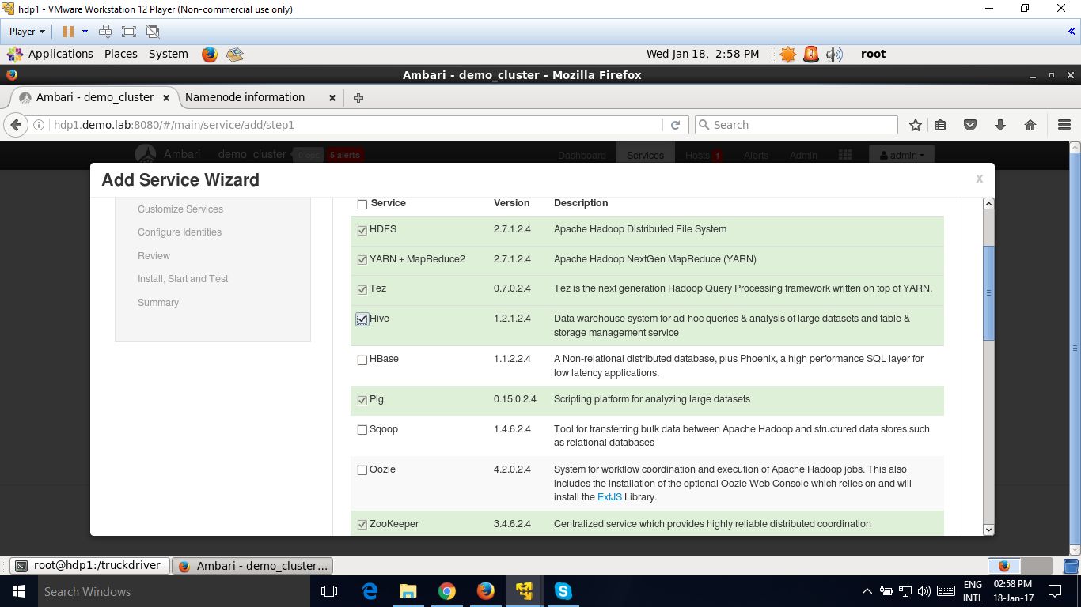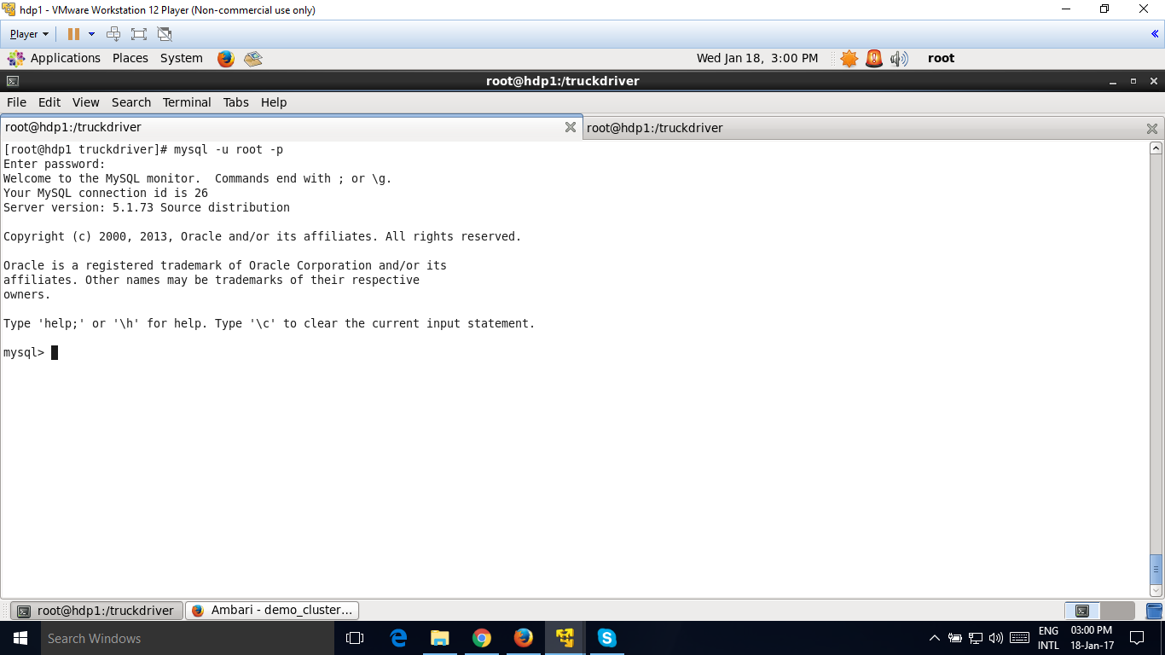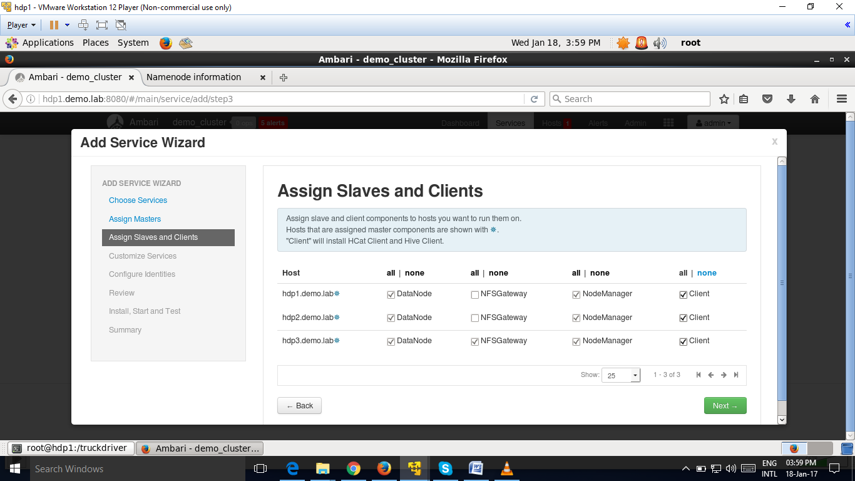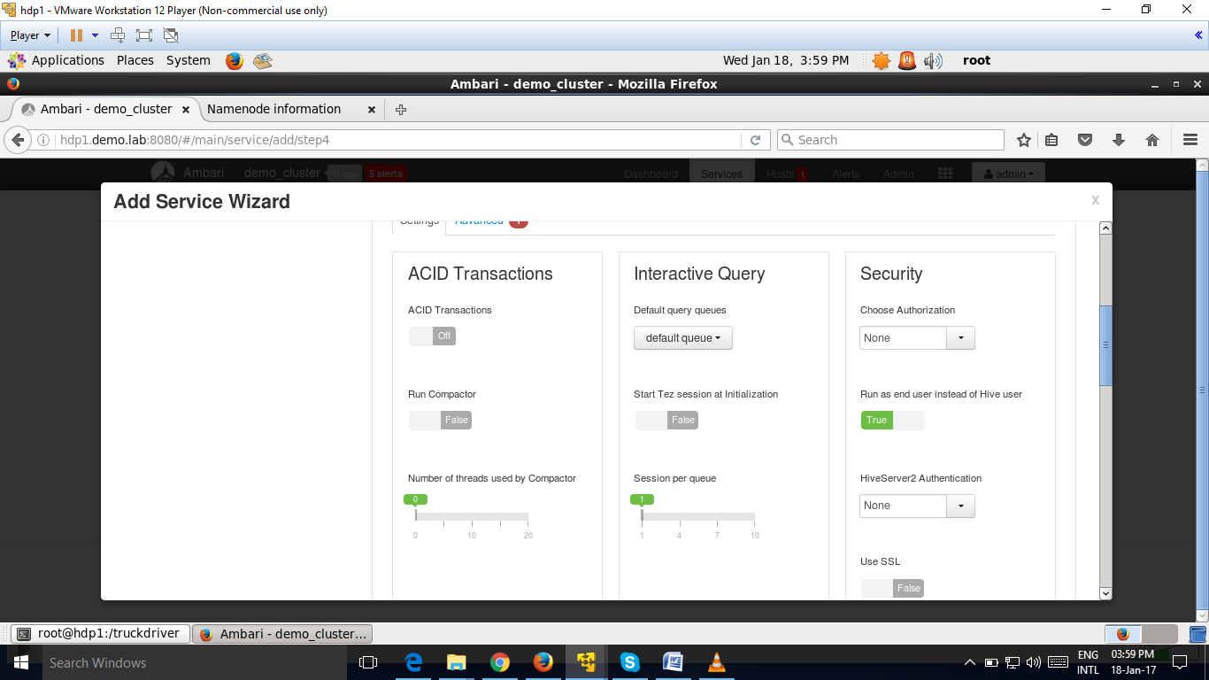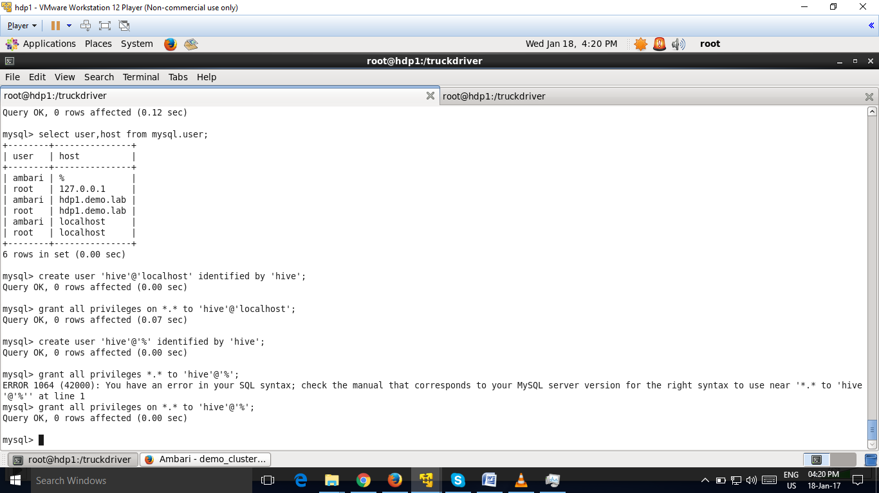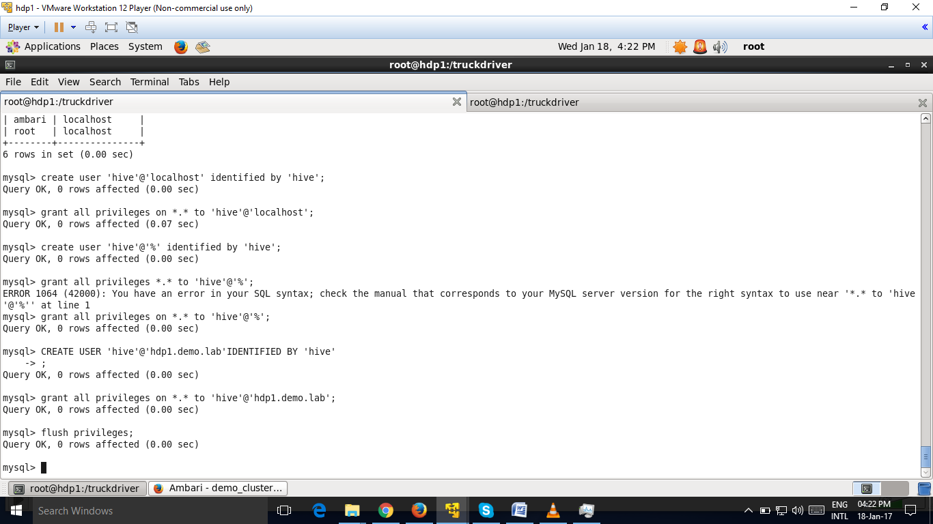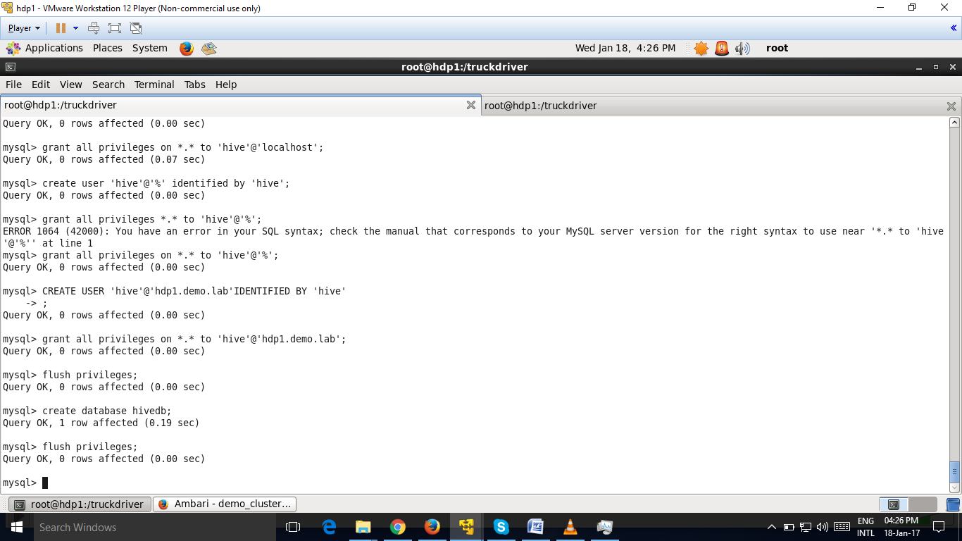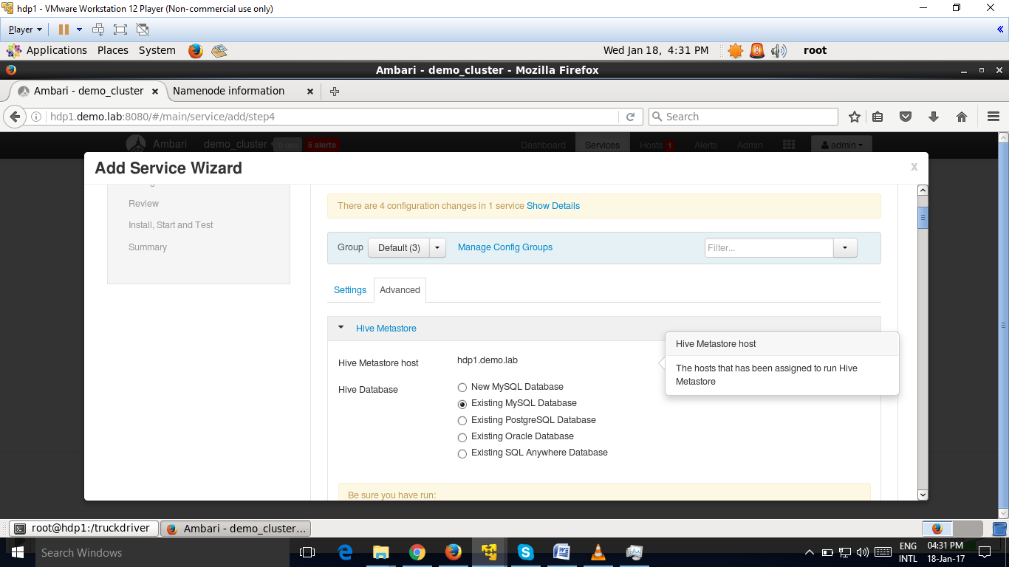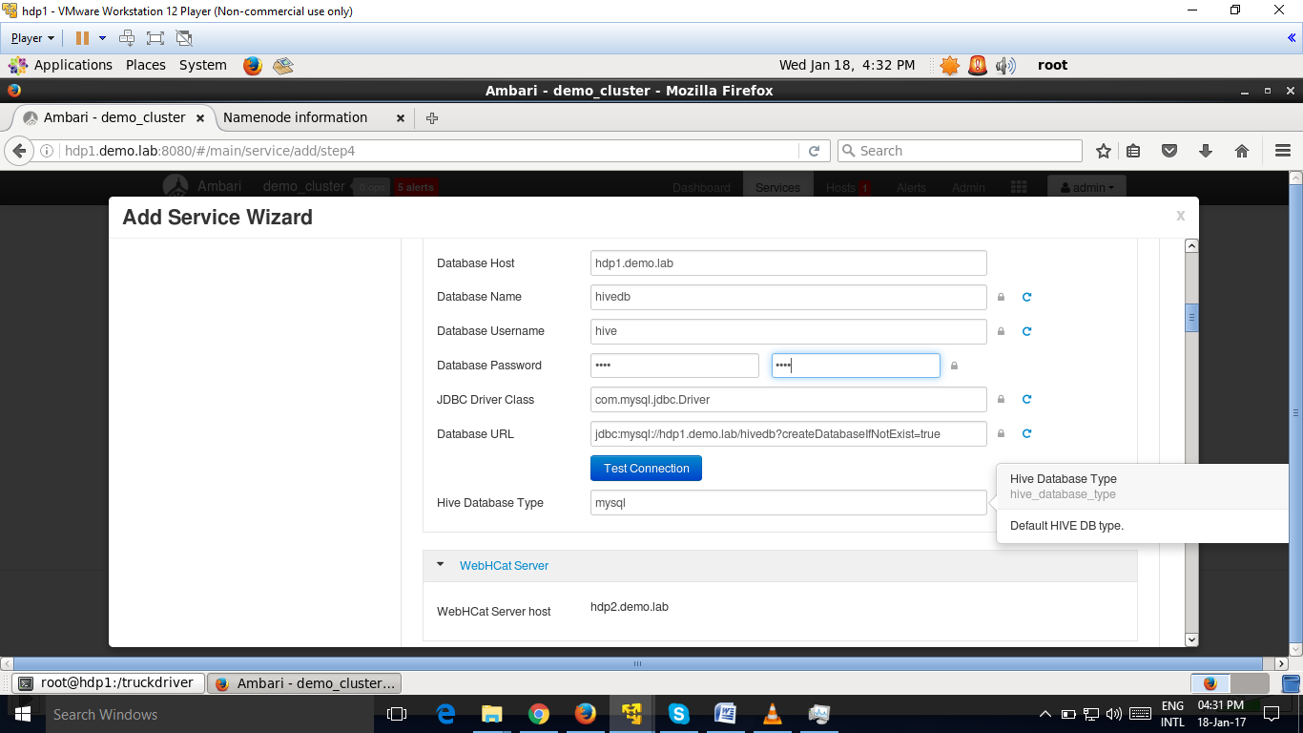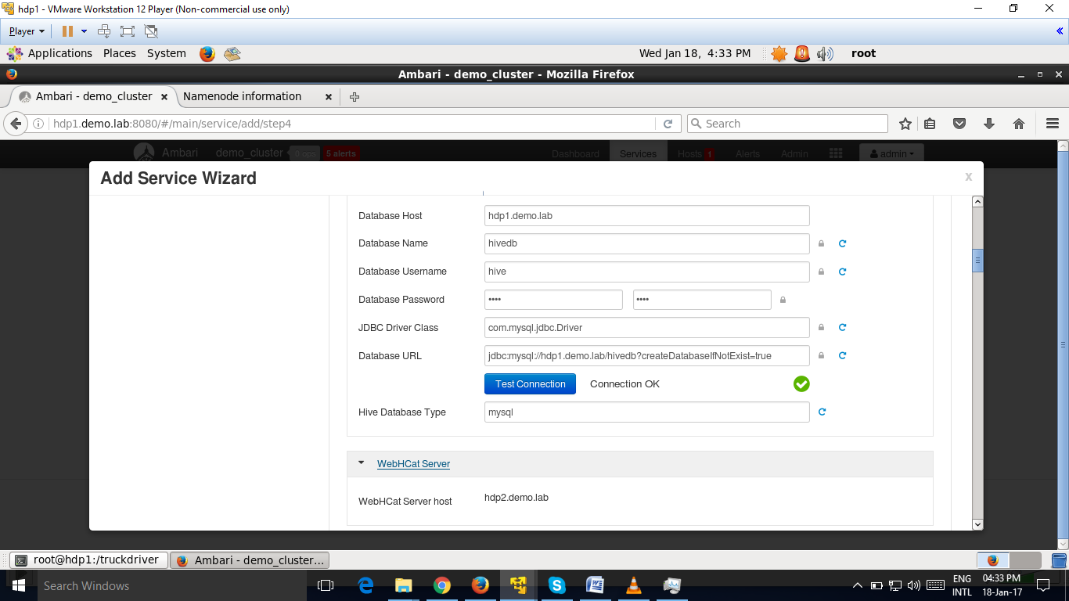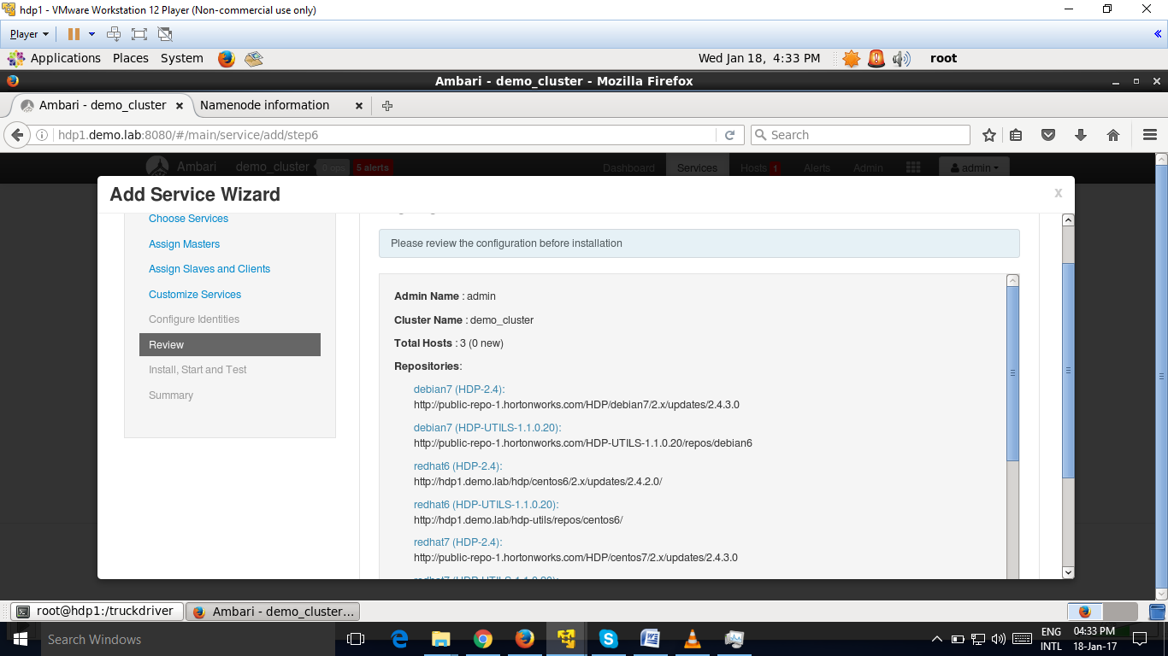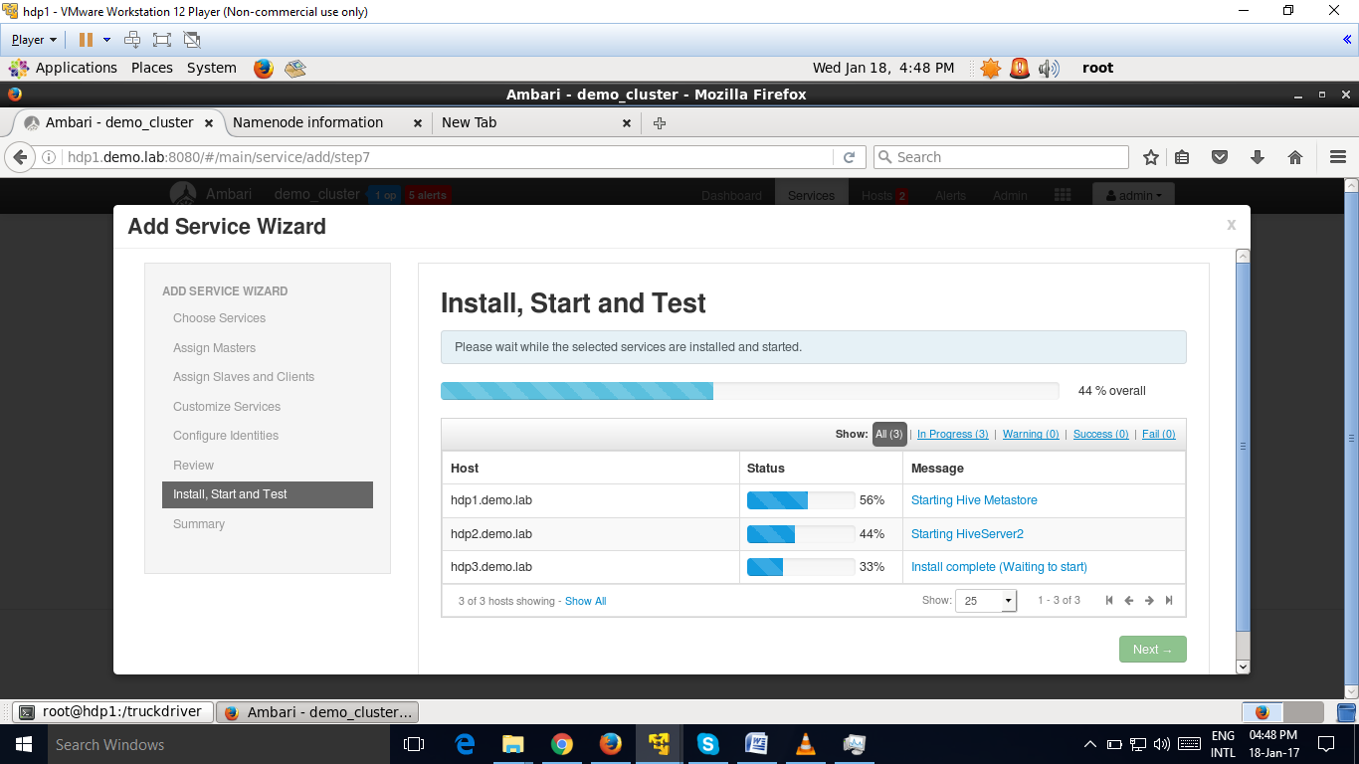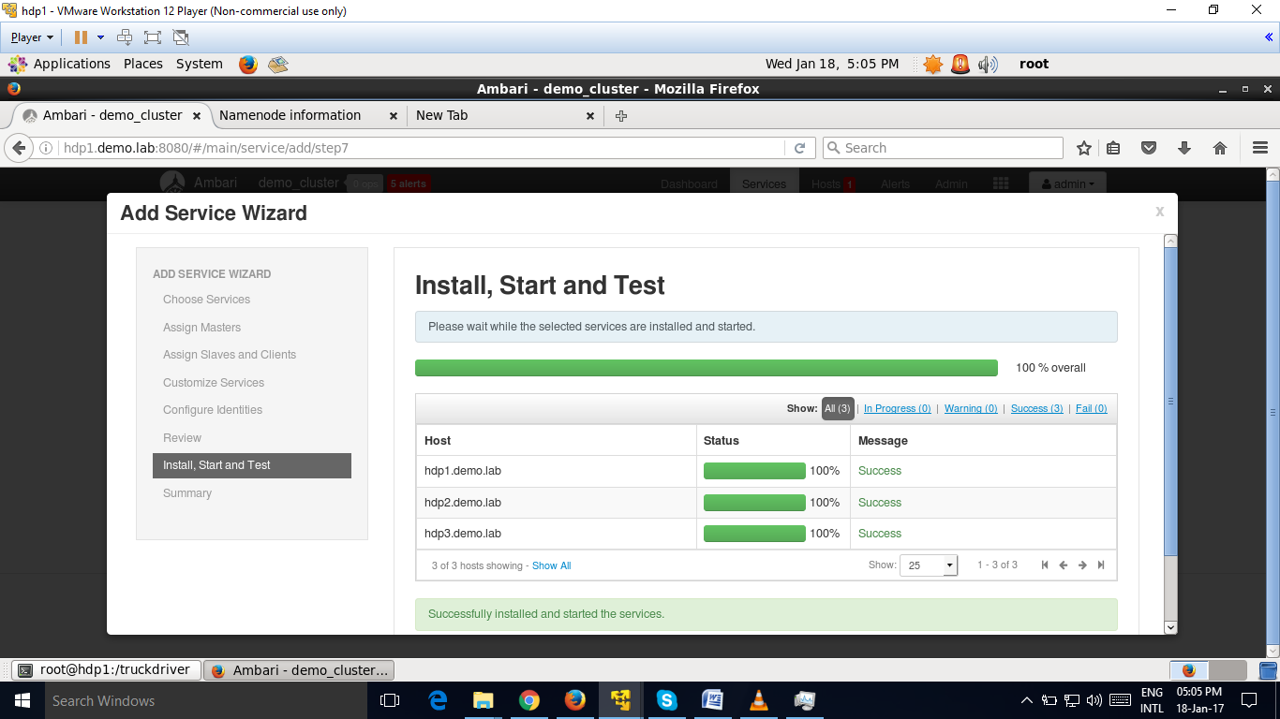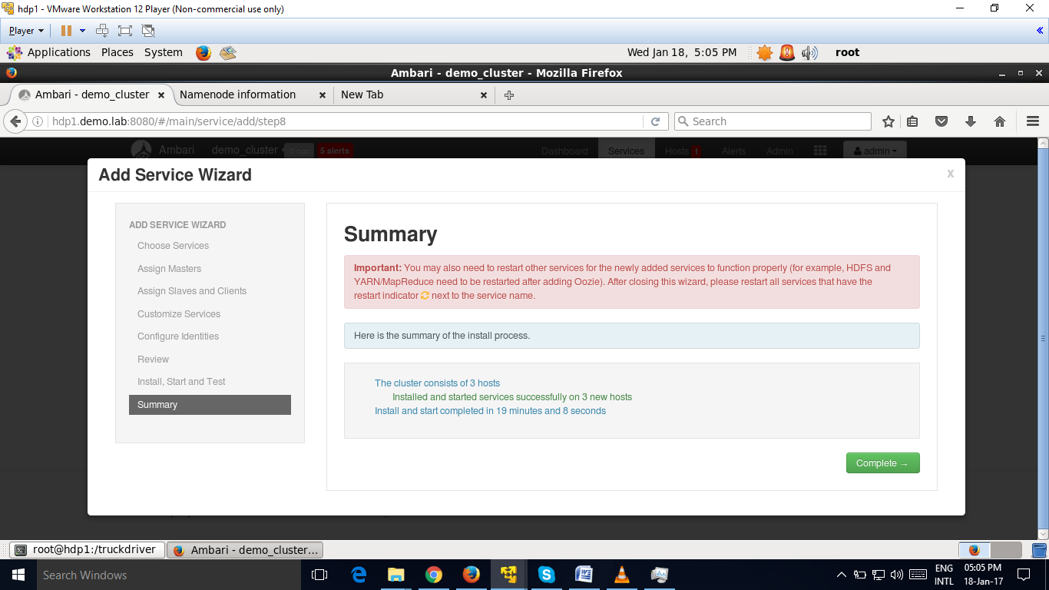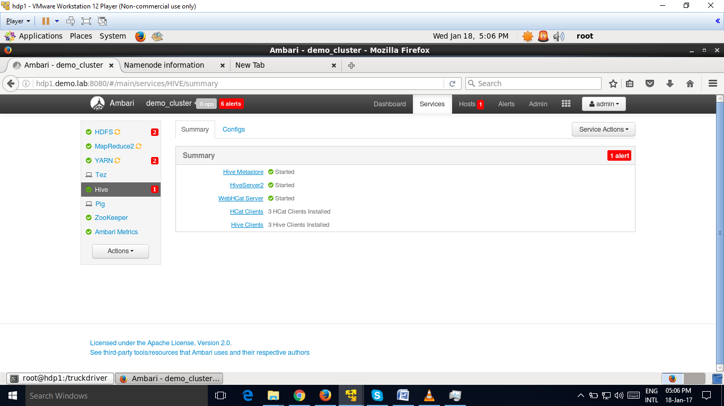

Hive is

A query engine wrapper built on top of MapReduce. • The Data warehousing solution in Hadoop. • The best tool for data analysts which provides HQL. • Effective in hiding the HDFS complexities from the end user. • Targeted mainly at users with SQL background.

